~50 subject in each condition: backward (b), forward (f), ~90 subject in random/control (r)

1. Average for each participant separated by correct rejection and hits

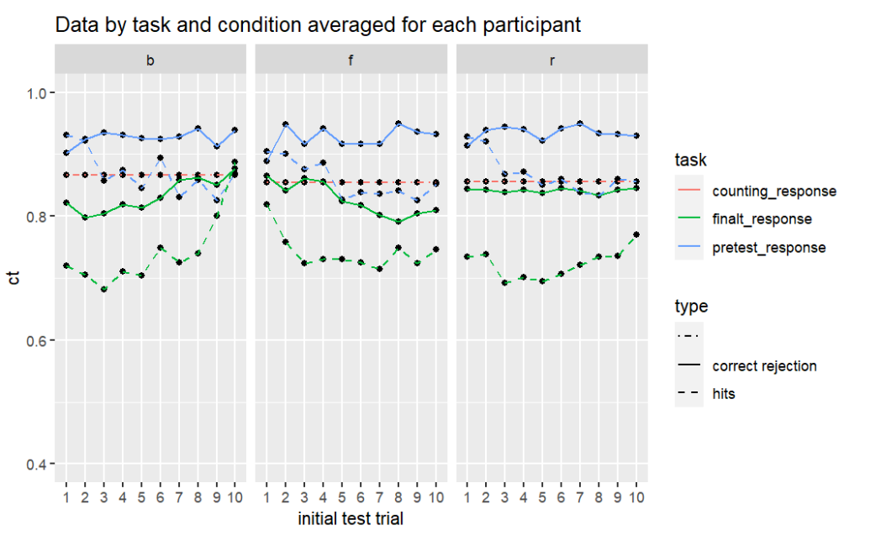

1. Average probability of correct separated by probetype

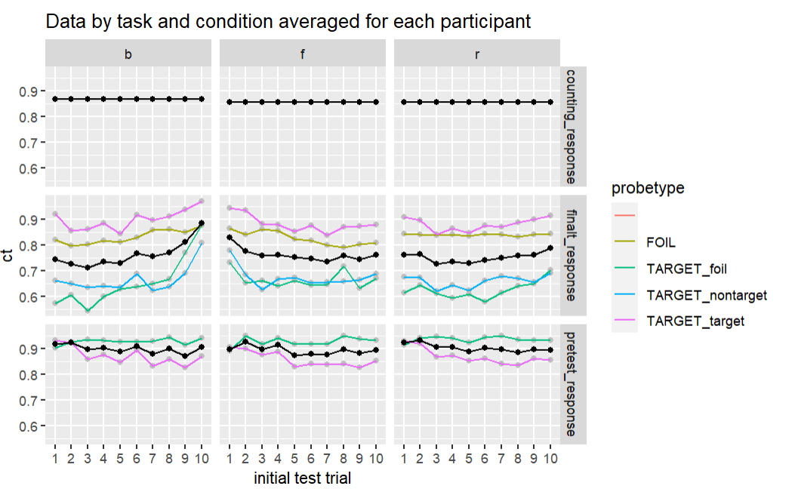

1. 3 condition’s Performance of final test by final test position

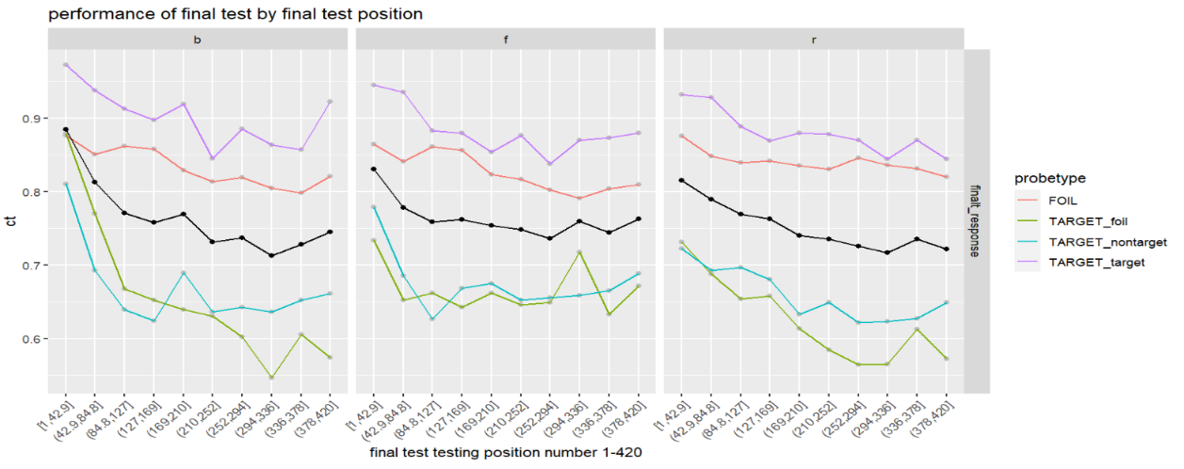

1. Conditional probability correct of post test based on pretest response

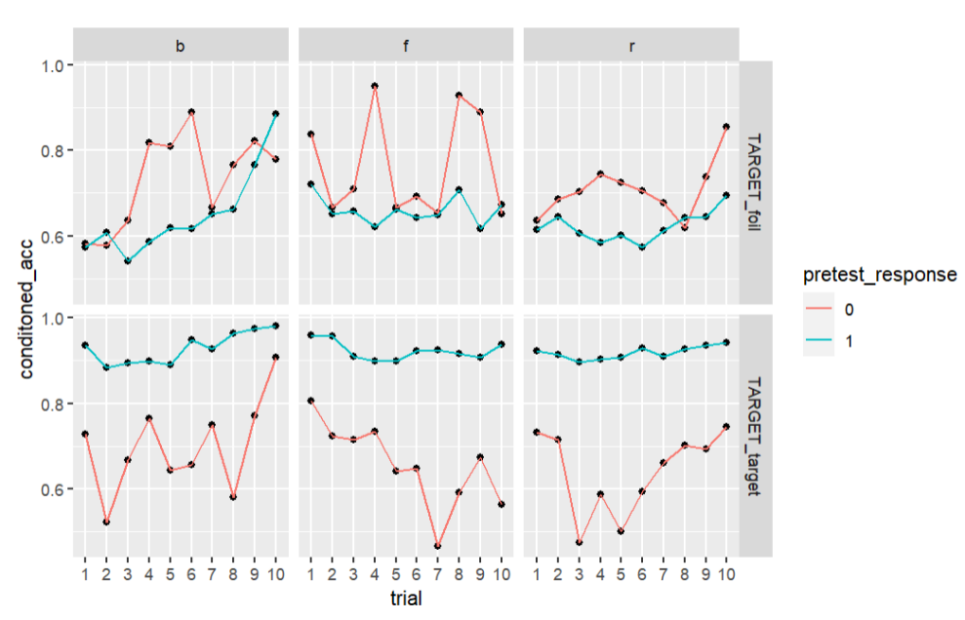

1. Serial position curve of post test by initial test & study position

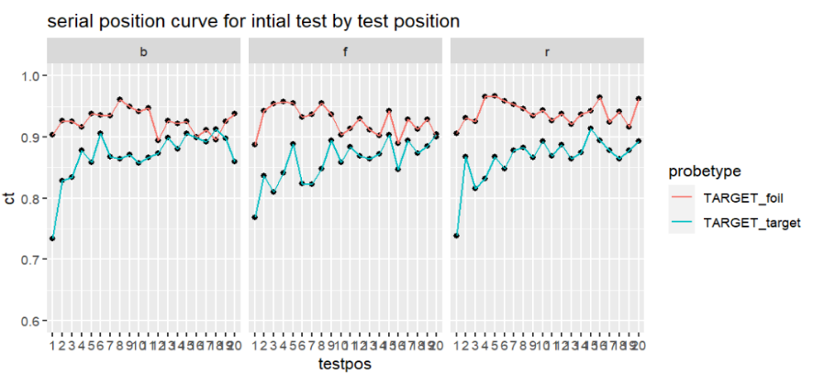

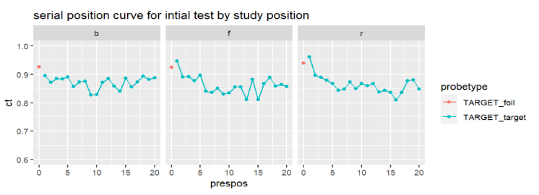

See next page

